**Name: Varsha JJ**

**Roll No: 48**

**Batch: B**

**Date: 04/04/22**

**NETWORKING & SYSTEM ADMINISTRATION LAB**

**Experiment No.: 4**

**Aim**

Familiarization of linux command.

**Procedure**

**34. cp file1 file2 :** If the command contains two file names, then it copy the contents of 1st file to the 2nd file. If the 2nd file doesn’t exist, then first it creates one and content is copied to it. But if it existed then it is simply overwritten without any warning.

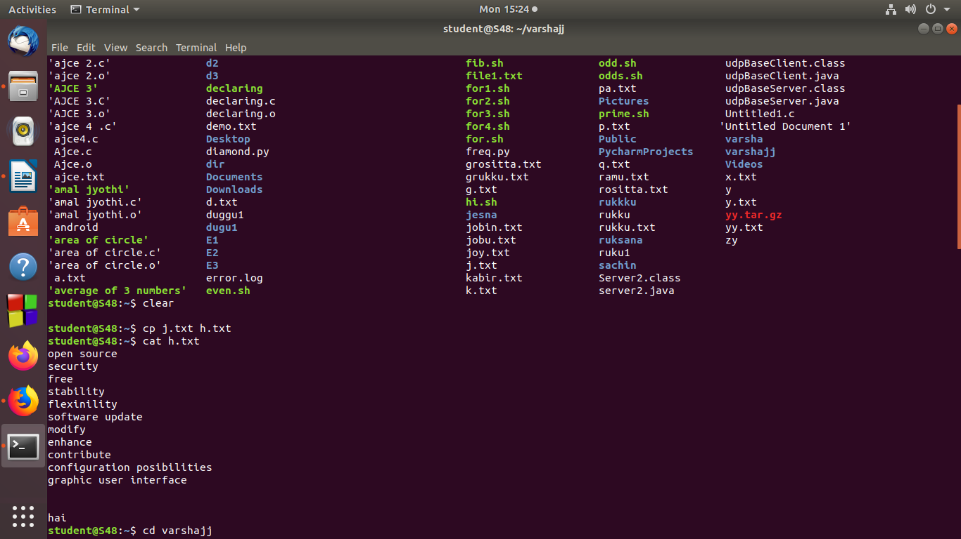

**35.cp -r** Src_directory Dest_directory : cp copies all files of the source directory to the destination directory, creating any files or directories needed. This mode of operation requires an additional option, typically R, to indicate the recursive copying of directories.

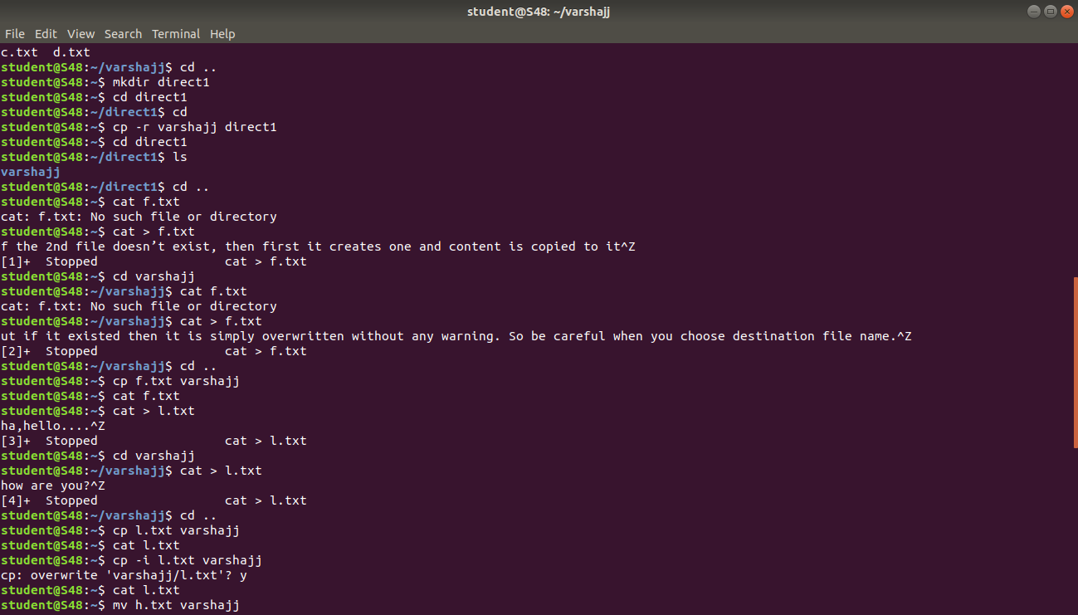

**36. cp -i file1 directory :** cp prompts for a response, if you press y then it overwrites the file and with any other option leave it uncopied.



**37. mv file.txt mydirect :** Move the file file.txt into the directory mydirect. If file.txt is a file, it is overwritten. If the file is marked as read-only, but you own the file, you are prompted before overwriting it.

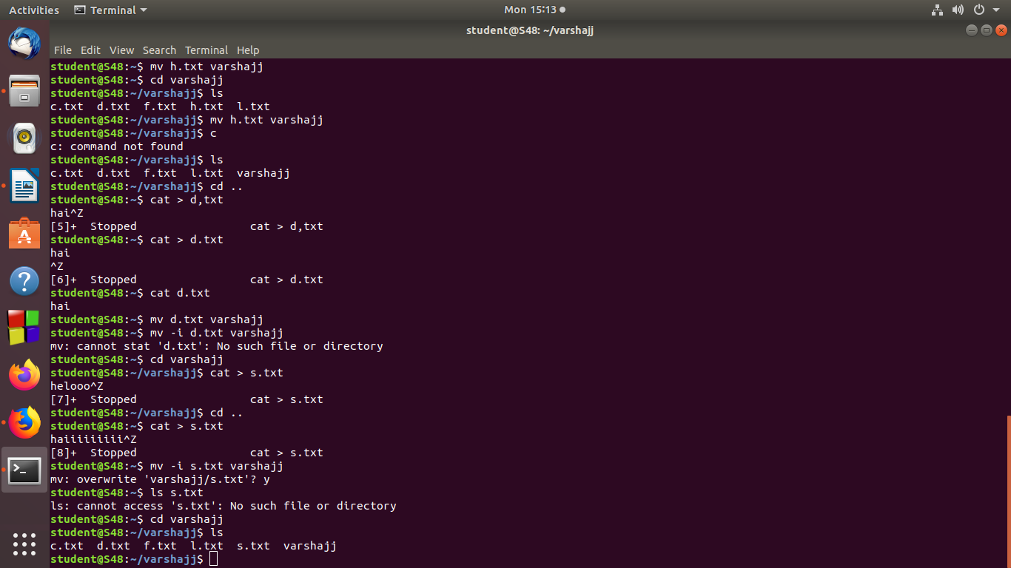

**38. mv -i file file2 :** If file2 exists and is a file, it is overwritten. If file2 exists and is a file, a prompt is given: mv: overwrite 'file2'?

Entering "y", "yes", "Yes", or "Y" results in the file being overwritten. Any other input skips the file.

